Name: _______________________________________________________ Date: _________________ Period: ________

Intermolecular Forces WebQuest
Go to the first link: https://tinyurl.com/qc68art
The simulation shows two types of molecules: a polar molecule and a non-polar molecule.
- Which one is the polar molecule? How can you tell?

- Assume that one molecule is HBr and another is Br₂. Which one is which? Explain.

Click and drag the molecules toward each other. Look for intermolecular attractions. After investigating, rank each of these statements as true or false.
______ Two non-polar molecules will attract each other.
______ A polar and non-polar molecule will attract each other.
______ On two polar molecules, the two positive ends will attract each other.
______ On two polar molecules, the two negative ends will attract each other.
______ On two polar molecules, the positive and negative ends will attract each other.

Sketch the attraction between two non-polar molecules:

Sketch the attraction between two polar molecules:

Go to the second link: https://tinyurl.com/yddkgnln
You are now going to compare the strength of the attractions between the molecules. Using the drop down menu, go through each of the options. Click and drag the green star to pull the molecules apart.
- Rank the forces of attractions from weakest to strongest based on your information:
Weakest Strongest

Reading: Types of Intermolecular Forces
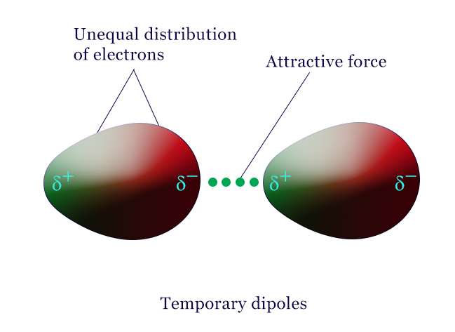
Molecular attraction is all about positive and negative regions in atoms attracting each other. All atoms contain protons and electrons—usually, the positive and negative charges are evenly distributed throughout the atom. However, electrons are always moving, and sometimes they get unevenly distributed. This causes the atom (or molecule) to have a positive side and a negative side. These positive and negative sides attract other atoms or molecules, and these attractions are called London Dispersion Forces, or LDFs for short. The diagram to the right shows how this works. The positive and negative sections are shown as ∂⁺ and ∂⁻. All molecules have London Dispersion Forces. LDFs are stronger in molecules that have more electrons, because they get larger positive and negative sections.
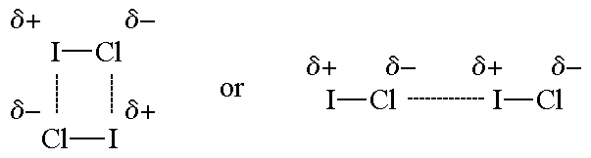
The second type of intermolecular forces are Dipole-Dipole Forces. This is what happens when molecules that are polar attract each other. Dipole-dipole forces are still based on the attraction between the positive and negative ends of molecules, but they are only present in molecules that are polar. The diagram below shows how these attractions can work. Dipole-dipole forces are stronger because the size of the charge is greater, leading to stronger Coulombic attraction.

- What causes attractions between polar molecules?

- What causes attractions between non-polar molecules?

- Why are dipole-dipole forces stronger than London dispersion forces?

Go to the third link: https://tinyurl.com/nd2klzd
Investigate the force of attraction between each of the molecules.
- Do these molecules show Dipole-Dipole or London Dispersion Forces? Explain.

- Compare small molecules to large molecules—which ones have larger LDFs? Why is this?

- How does molecule shape affect LDFs? Why is this?

Go to the fourth link: https://tinyurl.com/oort2r9
Intermolecular forces help us understand why molecules stick together. This affects the boiling point of substances. Click the play button at the bottom, then add heat.
- What happens to the motion of the molecules as you add heat?

- Which substance has a lower boiling point (meaning it breaks apart first)?

- Why do you think this is?

Go to the fifth link: https://tinyurl.com/prcp2mt
Some molecules have a special type of intermolecular force called Hydrogen bonds. Hydrogen bonds are not actually bonds, but are just really strong dipole-dipole interactions. Hydrogen bonds only happen in polar molecules that have one of the following bonds: F—H, O—H, or N—H. (Remember, hydrogen bonding is FON!)
- Using the simulation, use dashed lines to add hydrogen bonds to the diagram below:
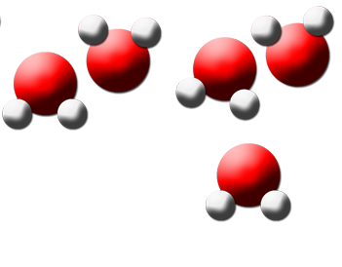
- Why do you think hydrogen bonds are stronger than normal dipole-dipole attractions?

Go to the sixth link: https://tinyurl.com/grw4qm8
On this link, you will observe what happen when a non-polar substance (oil) and a polar substance (water) are mixed. Click “Shake up oil and water mixture”, then click play.
- What happens to the oil/water mixture over time?

- Why do you think this happens?

Follow up questions:
- Rank the IMFs in order of strength.
Weakest Strongest

- How does their strength compare to covalent/ionic/metallic bonds?

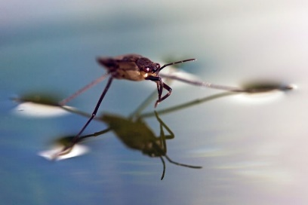
- Some insects can walk on the surface of water without breaking through, as shown in the picture to the right. This property is called surface tension. Explain using intermolecular forces why this happens.

- For each of the following molecules, circle ALL of the intermolecular forces present in the molecule:
A | 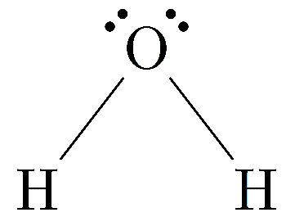 | LDFs | Dipole-Dipole | Hydrogen Bonds
B | 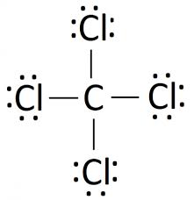 | LDFs | Dipole-Dipole | Hydrogen Bonds
C | 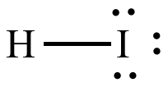 | LDFs | Dipole-Dipole | Hydrogen Bonds

Using the answer options above (A, B, C), predict the following properties based on the strength or amount of intermolecular forces:
- Which molecule will have the highest boiling point? _______________
- Which molecule will have the strongest surface tension? _____________
- Which molecule will have the strongest LDFs? _________________
- Which one will most easily mix with oil (a non-polar substance)? _______________
- Which one will most easily dissolve ionic compounds? ________________
The graph below shows the boiling points of the group 16 elements bonded with hydrogen:
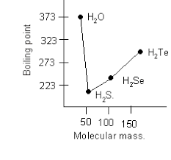
- Why does the boiling point increase as you go down the group for S, Se, and Te?

- Why is water’s boiling point so much higher than the rest of the group’s?

