AP Chemistry Le Chat Intro Webquest:

■■Context for This Investigation
Until now, most of the reactions studied have been assumed to go to completion. In these reactions, a color change was observed, a precipitate formed, or a gas evolved with bubbling or fizzing. These reactions had been carried out under conditions that favor product formation. In fact, though, for many chemical changes, under the correct conditions, the reaction does not go all the way to completion; rather, chemists say that an equilibrium state is reached, with some amounts of all reactants and products present in varying amounts. One equilibrium system that is constantly being stressed by changes in reaction conditions is responsible for the transport of oxygen and carbon dioxide in our bodies. The oxygen, O₂, is in equilibrium with the oxygenated (HbO₂) and deoxygenated (Hb) forms of hemoglobin, the iron-containing molecule in the blood that “carries” oxygen to our cells and carbon dioxide back to the lungs. The equilibrium can be represented as: Hb + O₂ HbO₂

In the lungs, the pressure of the oxygen is relatively high, so the reaction conditions, the “equilibrium,” is said to favor the formation of HbO₂ there. The oxygenrich blood then leaves the lungs and is carried to the cells of the body. Once the oxygenated hemoglobin reaches the cells where it is needed, the pressure of oxygen is much lower and the equilibrium no longer favors HbO₂, but rather the reverse (Hb). Thus, as a result of these new reaction conditions, the oxygen is “released” into the cell as the equilibrium is said to now favor the reactants. At the same time, the pressure of carbon dioxide is elevated in the cell and so the CO₂ molecule binds to the Hb molecule in an equilibrium similar to that
responsible for oxygen transport. When the blood reaches the lungs again, the carbon dioxide is “released” from the hemoglobin as the pressure of CO₂ is now lower and the reactants (Hb and CO₂) are now favored.

■■ Simulations
Students can then connect the stresses applied to the color changes observed in the system analyzed.
These animations are found under the heading “General Equilibria” on the Animations Index page at Iowa State University. Most of these animations will require shockwave. The link to all the animations is: http://group.chem.iastate.edu/Greenbowe/sections/projectfolder/animationsindex.htm

Animation 1: Cobalt Chloride Equilibrium
http://group.chem.iastate.edu/Greenbowe/sections/projectfolder/animations/CoCl2equilV8.html
Write out the reactions given to you as you proceed through the simulation. You will also need to indicate the colors of the given reactants and products. The equilibrium reaction will be given to you after the explanation of how the complex ion forms.

1. How does adding the Cl- ions to the cobalt complex ion change the reaction conditions?
2. How does adding water to the blue complex ion change the reaction conditions?
3. Why do these changes in conditions cause reactions to occur? Provide equations to illustrate how these changes in reaction conditions alter the position of the equilibrium. Relate it to rates of reactions.

Animation 2: NO₂ /N₂O₄ Equilibrium
http://group.chem.iastate.edu/Greenbowe/sections/projectfolder/animations/no2n2o4equilV8.html
You can view this one all at one time and then answer the following questions.
1. Each time the animation stops count the number of NO₂ and N₂O₄ molecules present. What do you observe?
2. After watching the animation panels that include the yellow arrows, describe what is happening simultaneously to keep the number of each type of molecule constant.
3. Explain how this animation illustrates the dynamic nature of equilibrium

Animation 3: Bromine Gas/Liquid Equilibrium
http://group.chem.iastate.edu/Greenbowe/sections/projectfolder/animations/equilvpBr2V8.html
You do not need to answer the questions within the online animation, only the ones below.

1. Is this a chemical equilibrium or a physical equilibrium?
2. How would you design an experiment to determine if this animation is an accurate representation of what actually occurs? (notice the colors of the reactants and products; think about experimental conditions you could change).

■■Read please! Explanation to Strengthen Student Understanding
In the introduction, the equilibrium system that is responsible for the transport of oxygen and carbon dioxide in your bodies was introduced. A related equilibrium involves carbon monoxide, a colorless, odorless gas that is produced by incomplete combustion and is poisonous to living organisms. Carbon monoxide (CO) reacts with hemoglobin in an equilibrium similar to that of oxygen:
Hb + CO HbCO
The reason that carbon monoxide is so poisonous is that the affinity between hemoglobin and carbon monoxide is approximately 200 times stronger than the affinity between hemoglobin and oxygen so hemoglobin binds more strongly to carbon monoxide. This means that a carbon monoxide poisoning victim will be starved of oxygen because carbon monoxide rather than oxygen is being transported in the blood. Because the affinity between carbon monoxide and hemoglobin is so strong, low concentrations of carbon monoxide can be harmful. In the United States, the Occupational Safety and Health Administration (OHSA) limits long-term workplace exposure levels to less than 50 ppm averaged over an 8-hour period and if a level of 100 ppm is reached employees must be evacuated from the area as it is unsafe. The symptoms include headaches and drowsiness at lower exposure levels, and unconsciousness and/or death with levels in excess of 1000 ppm for an hour. Treatment for carbon monoxide poisoning involves the administration of oxygen at high pressures, which increases the amount of oxygenated hemoglobin (HbO2) in the bloodstream. Chemical equilibrium means that there are forward and reverse reactions occurring simultaneously at equal rates. This means that the amounts of both the reactants and the products remain constant. That is, the reactants are consumed to generate products at the same rate the products react to regenerate the reactants. No net change in amount occurs. To the outside observer it looks as if nothing is happening because on the macroscopic scale, no properties of the reaction system change. This is known as a dynamic equilibrium.
Equilibrium systems can be described mathematically using the concentrations of solutions or pressures of gases in the mass action expression. The equilibrium constant is the mathematical result of these calculations. This equilibrium constant’s specific value is dependent upon the temperature at which the reaction occurs.
For the generalized reaction: aA(aq) + bB(aq) cC(aq) + dD(aq) the equilibrium constant, or mass action expression is K= [C]^{c} [D]^{d} / [A]ª [B]^{b}
where Kc is the equilibrium constant, and [ ] denotes the concentration of each substance.
The only substances included in the expression are those that have a concentration — that is, substances that are pure (solids or liquids) are not included in the expression. The solvent, water, is also omitted from the expression for dilute solutions as the concentration of water does not change appreciably.
Le Châtelier’s Principle
Henri Le Châtelier studied and published extensively on the subject of equilibrium in solutions. His principle has been interpreted in many different chemical systems, but essentially it states that:
“If a change in concentration, temperature, pressure, or volume is imposed on a chemical system at equilibrium, then the equilibrium shifts by changing concentration or pressure to counteract the imposed change and establish a new equilibrium.” These changes in conditions are often referred to as “stresses.” We say the equilibrium system has been “stressed” by the change and can predict the subsequent changes in concentration or pressure by examining the “stress.” The principle is applied to predict changes in the relative amounts of reactants and products, called the equilibrium position, in the following manner. For the generalized chemical reaction: aA(aq) + bB(aq) cC(aq) + dD(aq)
At constant temperature and pressure, adding substance A to the system when it is at equilibrium will cause a “stress” on the system by increasing the concentration of the reactant. An increase in the concentration of A will increase the rate of the forward reaction and the result will be an increase in the amounts of C and D, until their respective concentrations have risen to the point where the reverse reaction rate equals the forward reaction rate and equilibrium is restored. We say that the equilibrium position “shifts to the right.” Adding substance B would have the same effect for the same reason. A “stress” of removing either substance A or B would have the reverse effect. In this case, the reduction in the concentration of the reactants would cause the rate of the forward reaction to decrease and thus the momentarily faster reverse reaction would cause an increase in the concentration of the removed substance until they have risen to the point where the reverse reaction rate equals the forward reaction rate and equilibrium has been restored. In this case, Le Châtelier’s principle states that the equilibrium has adjusted to the stress by “shifting to the left.” Alternately, removing C or D, the products, would cause the equilibrium position to “shift to the right” and adding C or D would “shift it to the left.” These “shifts” would be due to increases or decreases in the rates of the reactions in one direction due to changing conditions.
In reactions involving gases, the pressure of the gas is important. The partial pressure of a gas is analogous to concentration, so increasing the pressure of a gas is the same as increasing the concentration of the substance. Reducing the pressure is the same as reducing the concentration of the substance. Changes in volume are commonly employed in chemistry to adjust gas pressures and in applying Le Châtelier’s principle special attention must be paid to the stoichiometry of the system. If the moles of gas present in the balanced equation are the same for both products and reactants, there will be no change in the position of the equilibrium due to a volume change; however, if they are different, then the equilibrium position will shift. This shift will be due to the changes in the rates of the reaction in response to the unequal changes in the partial pressures of the gases involved when the volume changes.
Finally, the equilibrium constant is temperature dependent. In your students’ study of chemical kinetics they will have observed that reaction rates depend upon temperature and, since equilibrium involves reaction rates, it naturally follows that the Kc value, and thus the position of an equilibrium, is temperature dependent. An increase in the temperature at which an endothermic reaction is performed will increase the rate of the forward reaction more than the rate of the reverse reaction and thus shift the reaction to the right. At the increased temperature, more reactant species will possess sufficient energy (the activation energy) to react and the rate for the forward will exceed the rate of the reverse, shifting the equilibrium position. The value of the equilibrium constant, Kc, is increased under the new, higher temperature conditions. The opposite is true for an exothermic reaction. In this case, lowering the temperature for an exothermic reaction will cause a shift to the right because, at the lower temperature, fewer reacting species will possess the activation energy and thus the rate of the reverse reaction will be greater, causing the shift to the right.

Part 2: LeChatelier’s Principle
Go to the sites shown here.
http://www.chem1.com/acad/webtext/chemeq/Eq-02.html
http://www.chem.ox.ac.uk/vrchemistry/ChemicalEquilibrium/HTML/page29.htm
http://www.youtube.com/watch?v=4-fEvpVNTlE See me for override if needed.

- What is a stress?
- If you add something (a reactant, product or heat/energy), will the equilibrium shift toward the side of the reaction to make even more of it, or will the equilibrium shift in the direction to use it up? Explain.
- If you remove a chemical or heat from a system, will the system shift toward the side that replaces what you took out or try to use even more of its?
- Explain what happens when you increase pressure on a system that was at equilibrium?
- What is the common ion effect? Give an example.

Part 3: Equilibrium AP Sample Questions (for #1-5 refer to the following):

A research group whose goal is to make an oxygen-carrying compound for use in artificial blood synthesized two candidate compounds, A and B. Each molecule of A or B can bind with one oxygen molecule (O₂). The equilibrium equations for the reactions between two compounds and oxygen are represented below. (Note: X--O₂ represents a molecule of X bound to an oxygen molecule.)

A + O₂ A--O₂ B + O₂ B--O₂

The research group made a 0.10 mM aqueous solution of each compound and added enough oxygen to create an initial concentration of 0.20 mM O₂. The following graphs show the change in the concentrations of the species after the oxygen was added at time = 0.

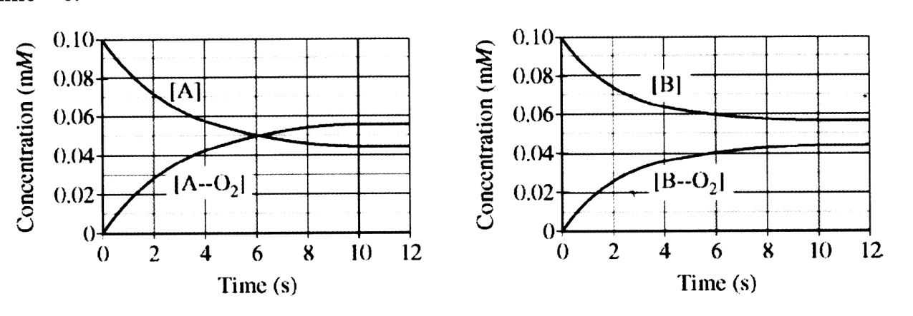
1. On the basis of the data above, what is the approximate concentration of O₂ when
compound A and O₂ have reacted for 4 seconds?
(A) 0.04 mM
(B) 0.06 mM
(C) 0.14 mM
(D) 0.16 mM
2. The binding of oxygen to A and the binding of oxygen to B are one-step elementary reactions. Which of the following is true regarding the rate constants of the forward reactions for the binding of O₂ to compound A and to compound B?
(A) The forward rate constants are equal.
(B) The forward rate constant is larger for compound A.
(C) The forward rate constant is larger for compound B.
(D) The forward rate constants cannot be determined from the data shown in the graph.
3. Which of the following is true regarding the equilibrium constants for binding of O₂ to compound A and to compound B?
(A) The equilibrium constants are equal.
(B) The equilibrium constant is larger for compound A.
(C) The equilibrium constant is larger for compound B.
(D) Reaction B has not reached equilibrium by 12 seconds, so there is not enough
information to determine the relative magnitudes of the equilibrium constants.
4. Which of the following statements about the rates of the forward and reverse reaction for compound A is correct?
(A) At 5 seconds the rate constant for the forward reaction is larger than at 12 seconds.
(B) At 5 seconds the reverse reaction rate is larger than the forward reaction rate.
(C) At 6 seconds the forward and reverse reaction rates are equal.
(D) At 12 seconds the forward and reverse reaction rates are equal.
5. The binding of oxygen to compound A is exothermic. If the reaction occurs in an insulated container, which of the following is the most likely result for a measurement of temperature of the reaction mixture versus time?
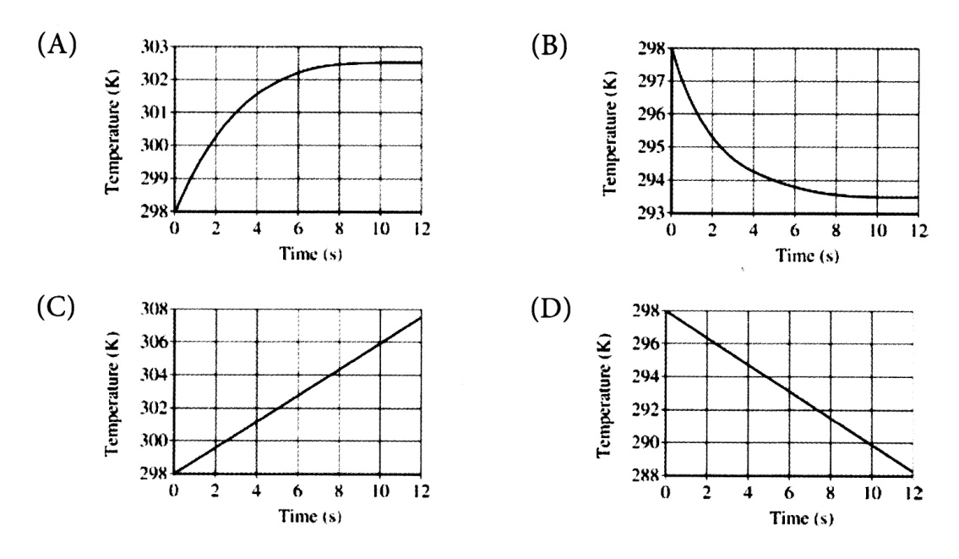
6. A + 2 B AB₂
The following diagram shows the change in concentration of reactant A and product AB₂ for the reaction represented by the equation above. The species A, B, and AB₂ are gases.
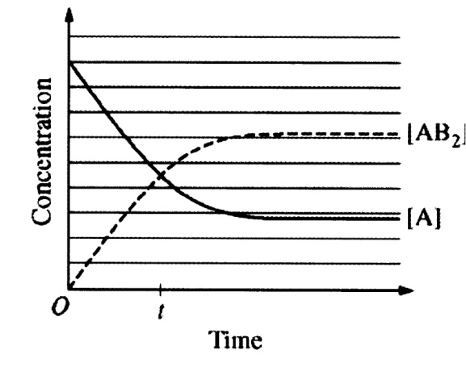
(a) Indicate on the diagram where the reaction reaches equilibrium.
(b) At time t, what is the relationship between Q, the reaction quotient, and K, the equilibrium constant? Explain your reasoning.
(c) At equilibrium, what is the relationship between the rate of decomposition of AB₂ and the rate of consumption of B for the reaction?
(d) For the same reaction at a different temperature, 6 moles of A and 9 moles of B are combined in a rigid 1.0 L container, and the system reaches equilibrium. If there are 3 moles of AB₂ present at equilibrium, what is the value of K for the reaction at this temperature?

Optional: Website for Graphical Analysis: http://msdiehl.com/resources/graphnotes.pdf

