Prokaryotic and Eukaryotic Cells
Essential Question: How are prokaryotic and eukaryotic cells alike and different?
Objectives:
- The student will be able to label and identify the general structures of prokaryotes and eukaryotes.
- The student will compare and contrast the structure of prokaryotic cells and eukaryotic cells.
Background:
Living things are made of cells. The variety of cells found in living things is astonishing. Scientists have determined there are two basic kinds of cells: prokaryotic and eukaryotic.
- Read the section that addresses prokaryotes and eukaryotes from the website: ck12.org Define the following terms:
Term | Definition
- prokaryotic
- eukaryotic
- organelle
- nucleus

The following activity will help you to determine the major differences between prokaryotic and eukaryotic cells.
Procedure:
- Divide the class into groups. Use the following links (https://www.livescience.com/65922-prokaryotic-vs-eukaryotic-cells.html, https://www.diffen.com/difference/Eukaryotic_Cell_vs_Prokaryotic_Cell) to complete the function of the cell structure function on the table below.

- Draw a large Venn diagram on the sheet of chart paper or butcher paper. Label the sections: Prokaryote, Both, Eukaryote. Write the cell structures into the correct section of the venn diagram.

- When you are finished ask your teacher to review the venn diagram. If placed incorrectly, the teacher will strike through the cell structure and placement should be reevaluated by the group. Indicate with a check mark the correct placement in your data table.

Results:
- Data Table: Prokaryotes vs Eukaryotes: a Comparison of Structure
Prokaryote | Eukaryote | Both | Cell Structures | Function
 |  |  | Cell Wall
 |  |  | Cell membrane (plasma)
 |  |  | DNA
 |  |  | Nucleus
 |  |  | Cytoplasm
 |  |  | Vacuoles
 |  |  | Endoplasmic Reticulum (rough)
 |  |  | Chloroplast
 |  |  | Golgi apparatus
 |  |  | Mitochondrion
 |  |  | Ribosomes
 |  |  | Lysosomes

Evidence of Mastery
Prokaryotic Cell Eukaryotic Cell

Analysis:
Write the answer to these questions in complete sentences on your own sheet of paper. Attach to the back of this paper.
- The cell shown below is a prokaryotic/eukaryotic cell. How do you know?
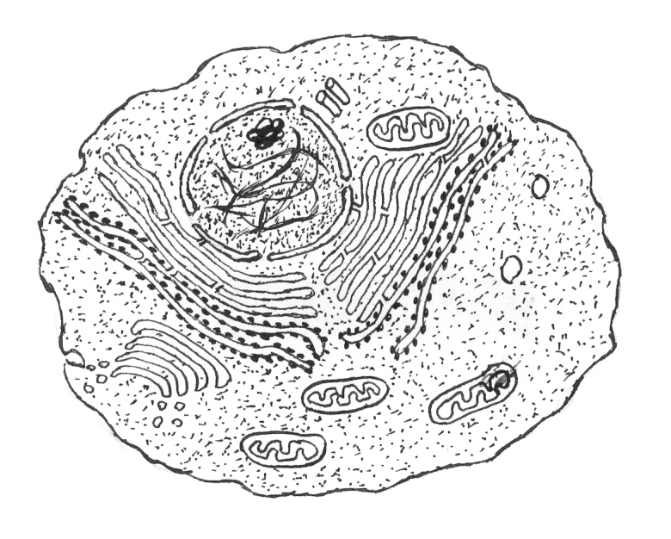
Wikimedia Commons (CC BY-SA 3.0)
- Which of these structures do prokaryotes and eukaryotes share? List all that apply.
- nucleus b. cell wall c. organelles d. plasma membrane e. ribosomes
- In paragraph form, compare and contrast the structure of prokaryotic and eukaryotic cells.

